**Tools for the class**

* **setup GitHub for saving your work**

1. Creating an account

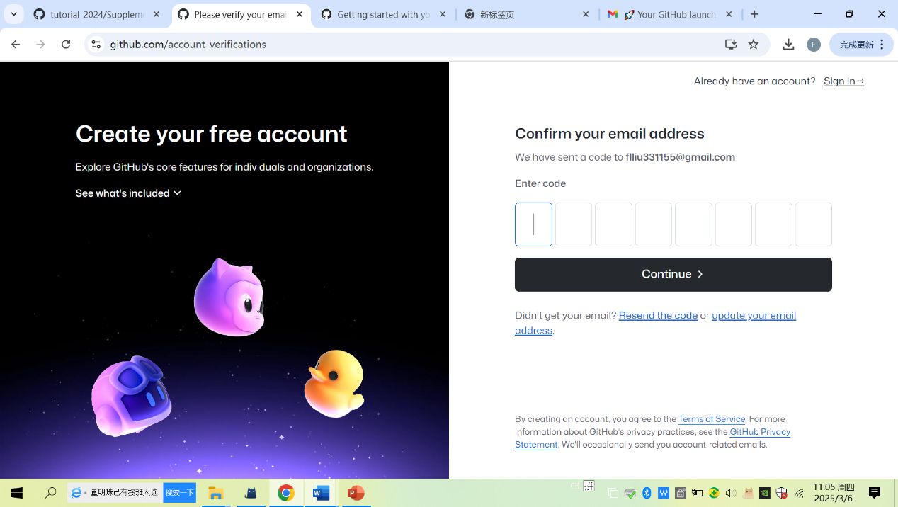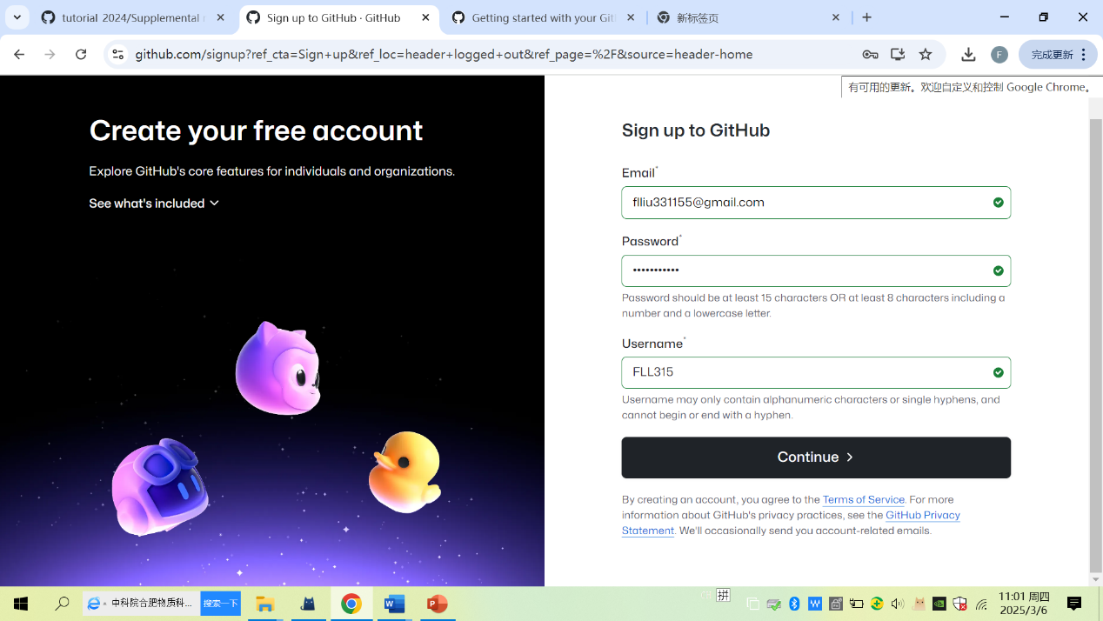

2. Configuring 2FA authentication

Setting >>password and authentication (scan OR code using google authenticator)

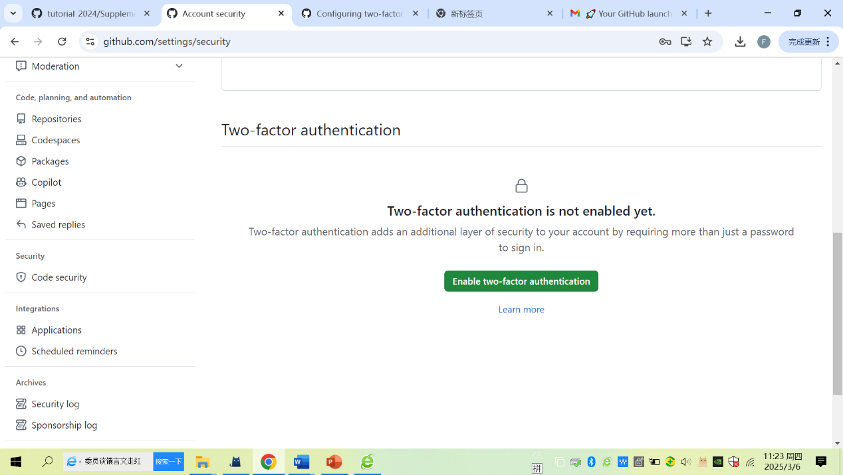

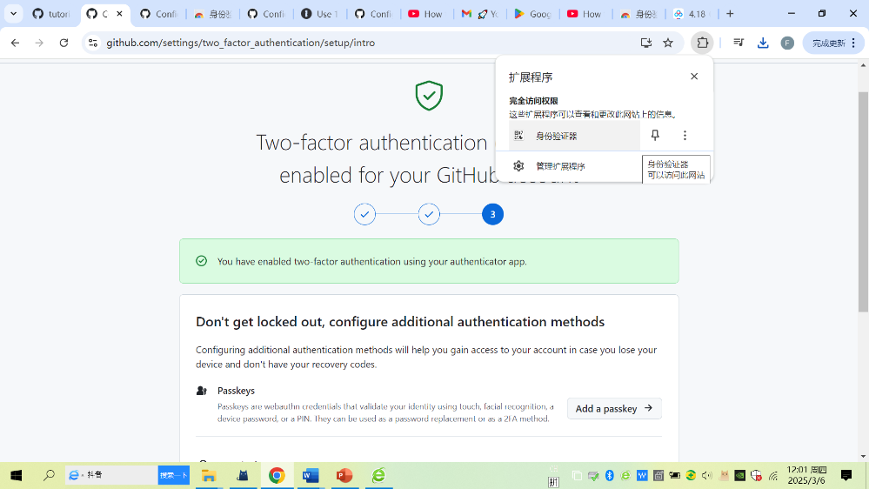

* **Setup virtual env for installing rdataretriever/keras/tensorflow packages**

1. install venv modulate in ubuntu

Run python3 --version，check whether python 3 is installed

*python3 –version*

run the following commands, install python3-venv for creating venv

*sudo apt install python3-venv*

*sudo apt install python3-pip*

*pip3 install virtualenv*

2. install reticulate package in Rstudio

Reticulated can be run in both RStudio and Python，install python packages via py_install()

*Install.packages(‘reticulate’)*

*reticulate::virturalenv_create(“r-reticulate”) # reboost*

3. setup virtual environment in Ubuntu

There are two ways to do, you can select one for your own system

One way is via RStudio

*Open RStudio→tootls→global option→system*

Another way is via Ubuntu terminal by running the following commands

*sudo vim /usr/lib/R/etc/Renviron*

*RETICULATE_PYTHON="/home/tank/.virtualenvs/r-reticulate/bin/python"*

4. activate virtual environment to install retriever、keras and tensorflow by two ways

*In Ubuntu terminal，first activate virtual environment and then pip install retriever、keras、tensforflow√*

*In RStudio，using py_instwall() to install rdataretriver、keras、tensorflow*

* **Install and configure the databases of SQLite and PostgreSQL**

1. SQLite (https://datawookie.dev/blog/2015/09/setting-up-odbc-for-sqlite-on-ubuntu/)

2. install and configure PostgreSQL

*:~$ sudo lsb_release -a*

*:~$ sudo apt update*

*::~$ sudo sh -c 'echo "deb http://apt.postgresql.org/pub/repos/apt/ focal-pgdg*

*::~$ sudo apt update*

*::~$ sudo apt-get -y install postgresql postgresql-contrib*

*::~$ sudo service postgresql status*

*::~$ cat /etc/passwd*

*::~$ sudo -i -u postgres*

*postgres@ubuntu:~$ psql*

*postgres=# \l*

*postgres=# exit*

*postgres@ubuntu:~$ exit*

*::~$ cd /etc/postgresql/15/main*

*::/etc/postgresql/15/main$ sudo vim postgresql.conf*

*::/etc/postgresql/15/main$ sudo vim pg_hba.conf*

*::/etc/postgresql/15/main$ sudo service postgresql restart*

*::/etc/postgresql/15/main$ sudo service postgresql status*

*::~$ sudo -i -u postgres*

*postgres@ubuntu:~$ psql*

*postgres=# create role admin with*

*postgres-# login*

*postgres-# superuser*

*postgres-# createdb*

*postgres-# createrole*

*postgres-# inherit*

*postgres-# replication*

*postgres-# connection limit -1*

*postgres-# password 'admin';*

*postgres=# \q*

*postgres@ubuntu:~$ exit*

*::/etc/postgresql/15/main$*

*::/etc/postgresql/15/main$ sudo curl https://www.pgadmin.org/static/packages_pgadmin_org.pub | sudo apt-key add -*

*::/etc/postgresql/15/main$ sudo sh -c 'echo "deb https://ftp.postgresql.org/pub/pgadmin/pgadmin4/apt/$(lsb_release -cs) pgadmin4 main" > /etc/apt/sources.list.d/pgadmin4.list & apt update'*

*::/etc/postgresql/15/main$ sudo apt install pgadmin4-web*

*::/etc/postgresql/15/main$ sudo sh -c 'echo "deb https://ftp.postgresql.org/pub/pgadmin/pgadmin4/apt/focal pgadmin4 main" > /etc/apt/sources.list.d/pgadmin4.list'*

*::/etc/postgresql/15/main$ sudo /usr/pgadmin4/bin/setup-web.sh*

*Email address: flliu513@163.com*

*pgAdmin 4 - Application Initialisation*

*::/etc/postgresql/15/main$ sudo ufw allow 80/tcp*

*::/etc/postgresql/15/main$ sudo ufw enable*

*::/etc/postgresql/15/main$ sudo ufw status*

* **make a sure that R’s package of qgisprocess work**

compile postgis-3.4.1

tar zxvf postgis-2.1.2.tar.gz

cd postgis-2.1.2

./configure --with-pgconfig=/usr/local/pgsql/bin/pg_config

make

make install

https://trac.osgeo.org/postgis/ticket/5222

SELECT * FROM pg_available_extensions WHERE name LIKE 'postgis';

CREATE EXTENSION postgis_raster SCHEMA public VERSION unpackaged;

CREATE EXTENSION postgis_topology SCHEMA topology VERSION unpackaged;

Install saga 9.3.1

1. first needing to install wxwidgets3.2 as follows:

<https://juejin.cn/post/7283798844236218403>

<https://launchpad.net/~hrzhu/+archive/ubuntu/wxwidgets3.2-backport>

Adding this PPA to jemmy system

sudo add-apt-repository ppa:hrzhu/wxwidgets3.2-backport

sudo apt update

install via terminal or manual synati

sudo apt-get install libwxbase3.2-0-unofficial \

libwxbase3.2unofficial-dev \

libwxgtk3.2-0-unofficial \

libwxgtk3.2unofficial-dev \

wx3.2-headers \

wx-common \

2. second install download saga

1) Install saga 9.3.1

sudo add-apt-repository ppa:johanvdw/saga-gis

sudo apt-get install saga

2) saga 9.3.1.tar.gz and compile it

<https://sourceforge.net/p/saga-gis/wiki/Binary%20Packages/>

git clone git://git.code.sf.net/p/saga-gis/code saga-gis-code

cd /saga-gis-code

mkdir build

cd build

cmake ../saga-gis -DCMAKE_BUILD_TYPE=RELEASE -DWITH_TRIANGLE=OFF -DWITH_SYSTEM_SVM=ON -DWITH_DEV_TOOLS=OFF

cmake --build . --config Release

sudo cmake --install .